Experiment No: 2

Exploratory Data Analysis (EDA) – Data Import and Export

Aim
To import the KaggleV2-May-2016.csv dataset using Pandas, inspect and analyze the dataset, perform basic exploratory data analysis (EDA), and export the processed data into different file formats.

Algorithm
- Import the required Python libraries.
- Load the healthcare dataset (KaggleV2-May-2016.csv) using pd.read_csv().
- Display the first few records using head().
- Display the dataset information using info().
- Display statistical summary using describe().
- Display the column names.
- Check the shape of the dataset.
- Check for missing values.
- Check for duplicate records.
- Display unique values of each column.
- Visualize the relationship between selected variables using a scatter plot.
- Separate the feature variables (X) and target variable (y).
- Export the processed dataset into CSV, Excel, and JSON formats.

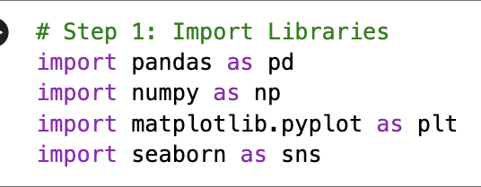

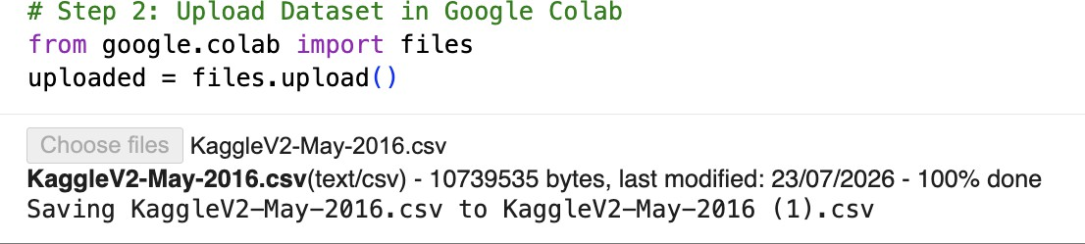

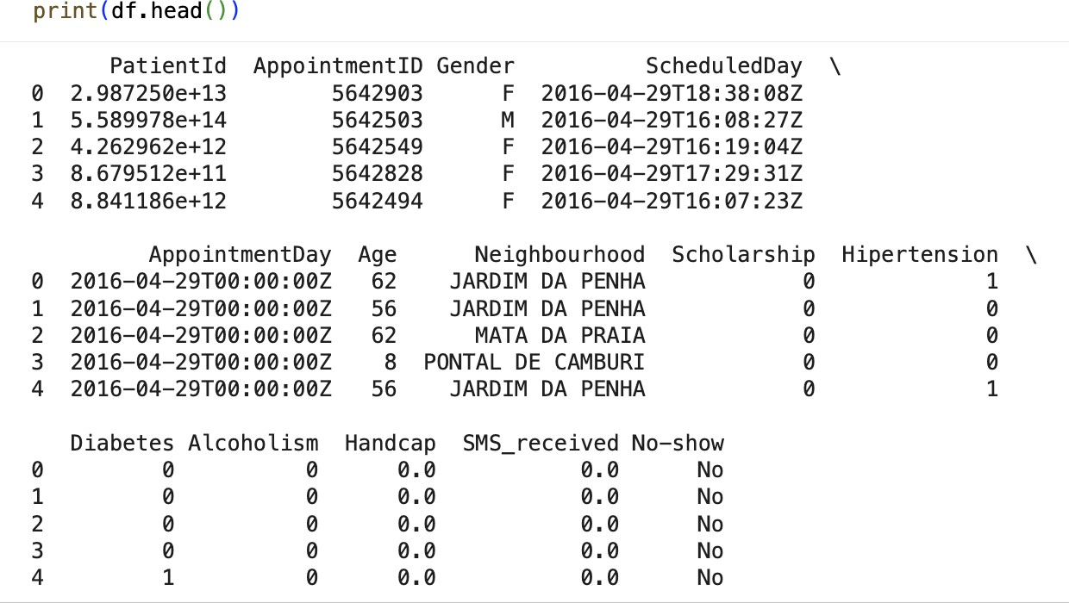

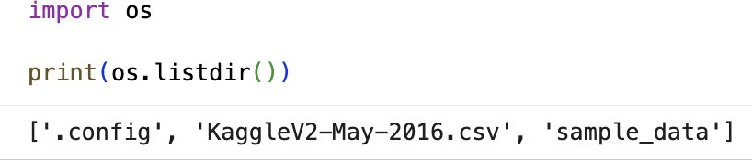

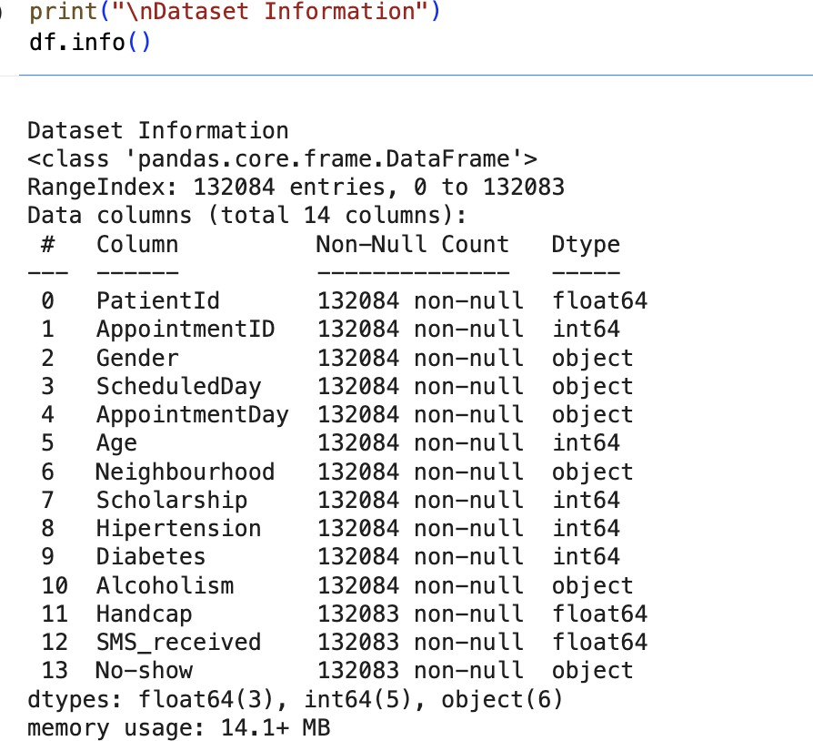
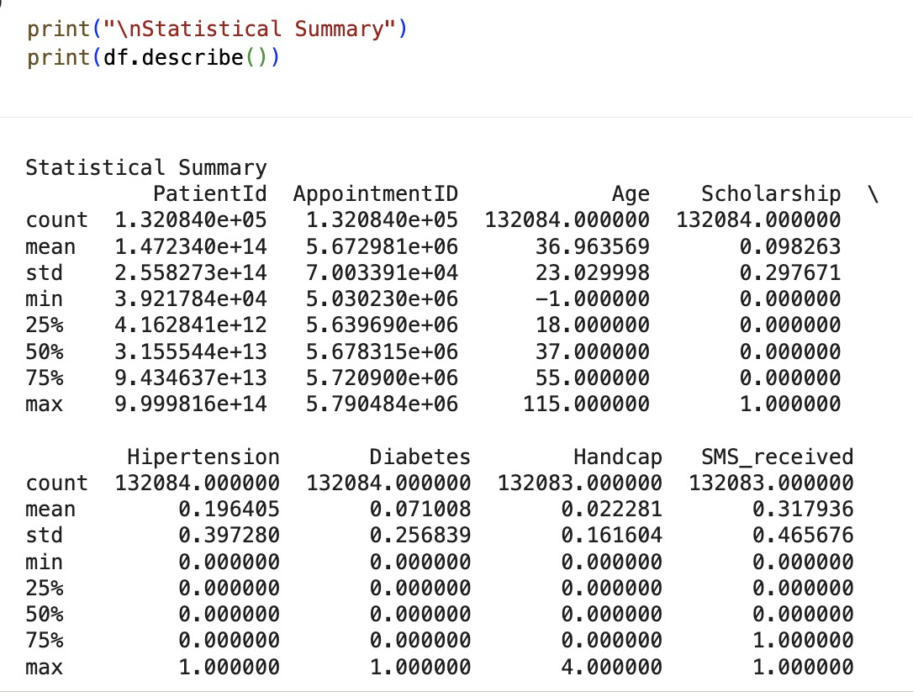

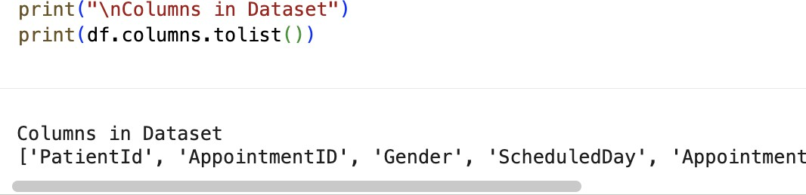

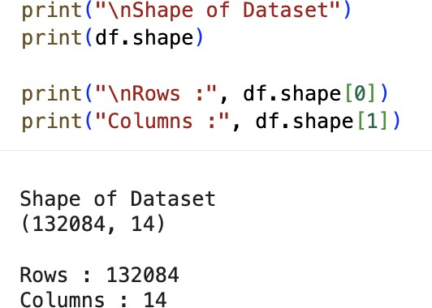

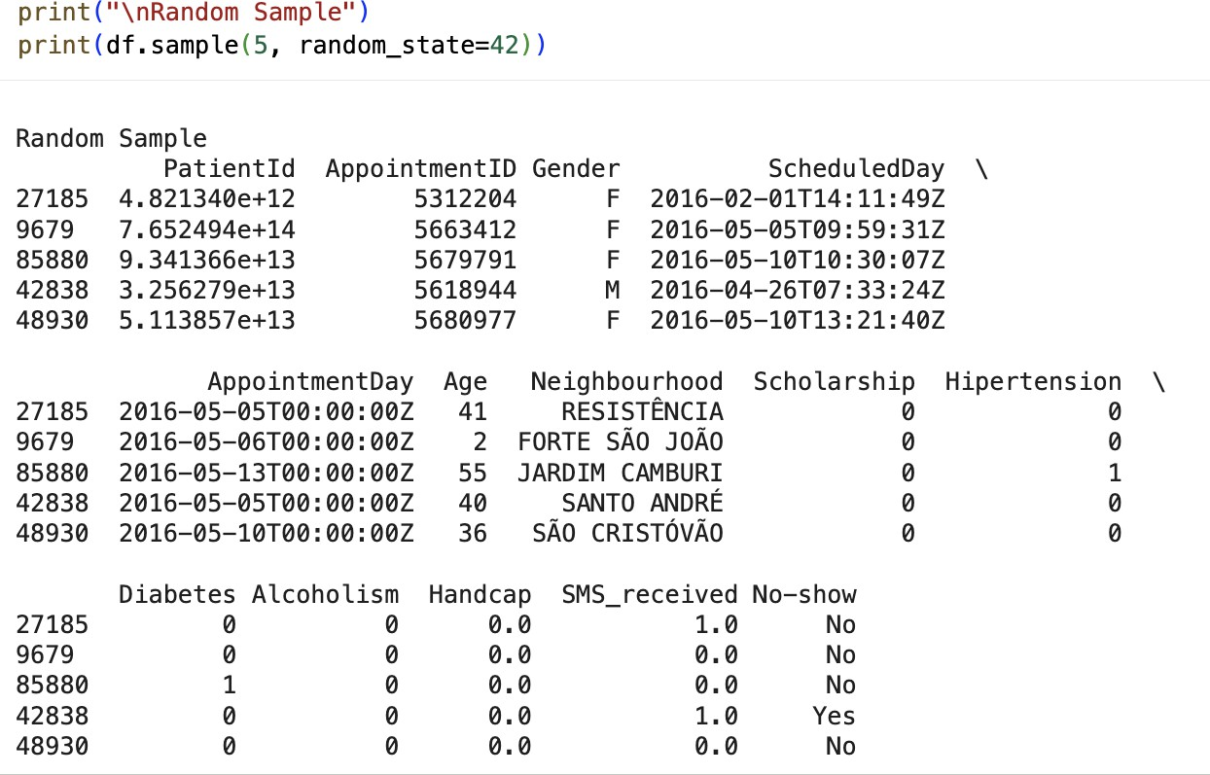

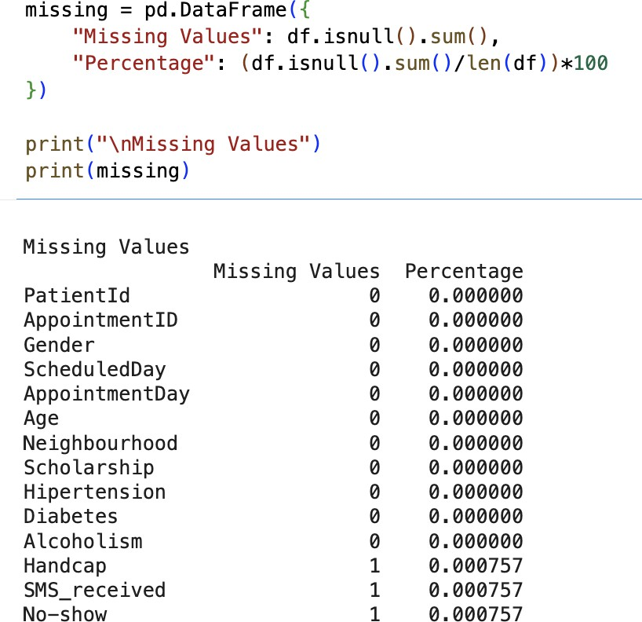

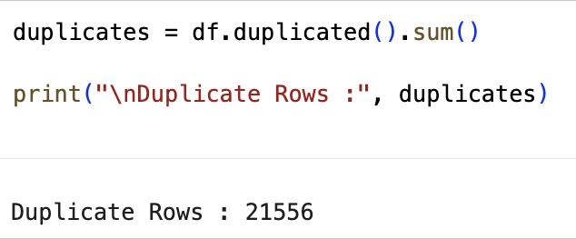

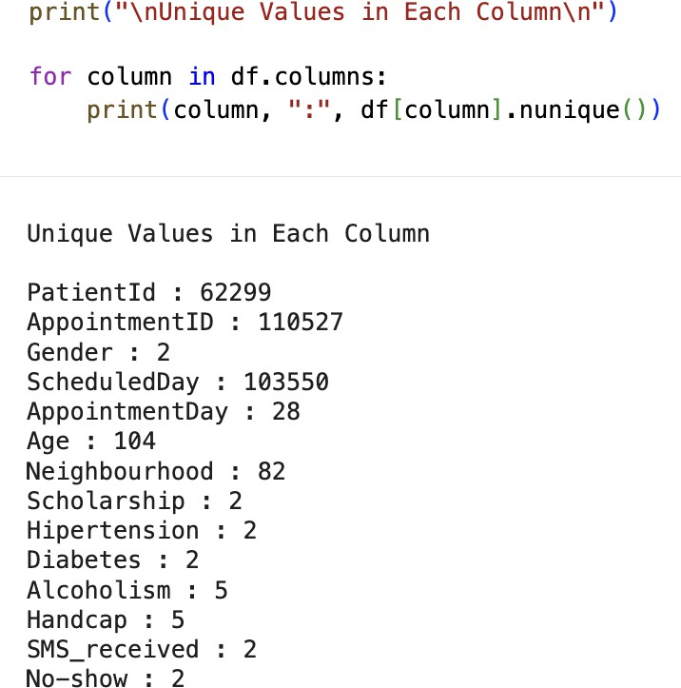

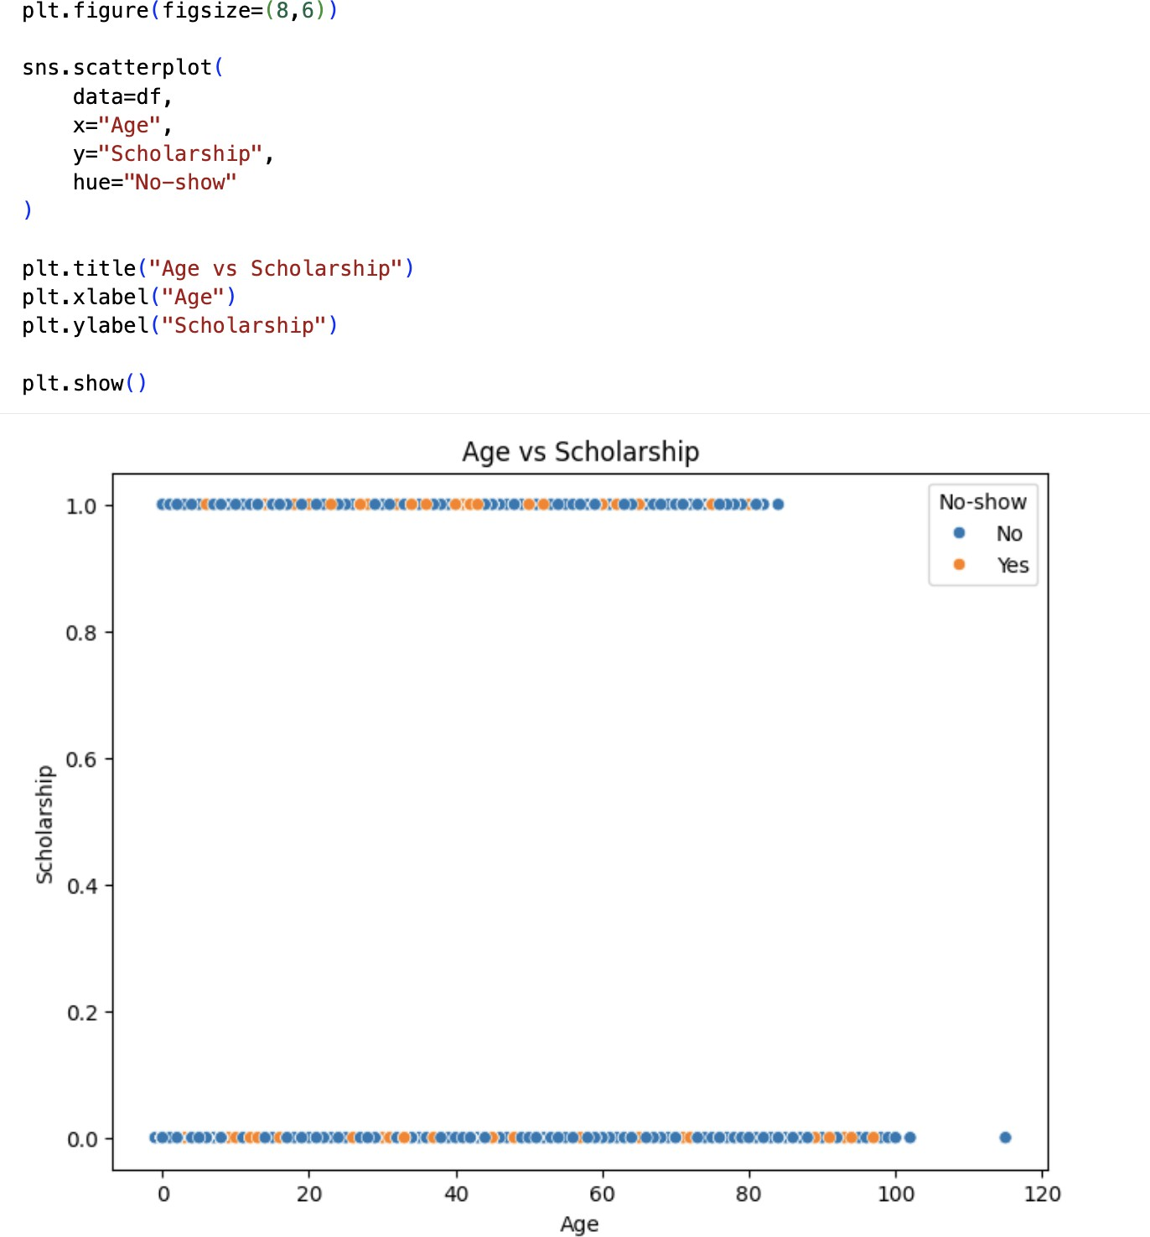

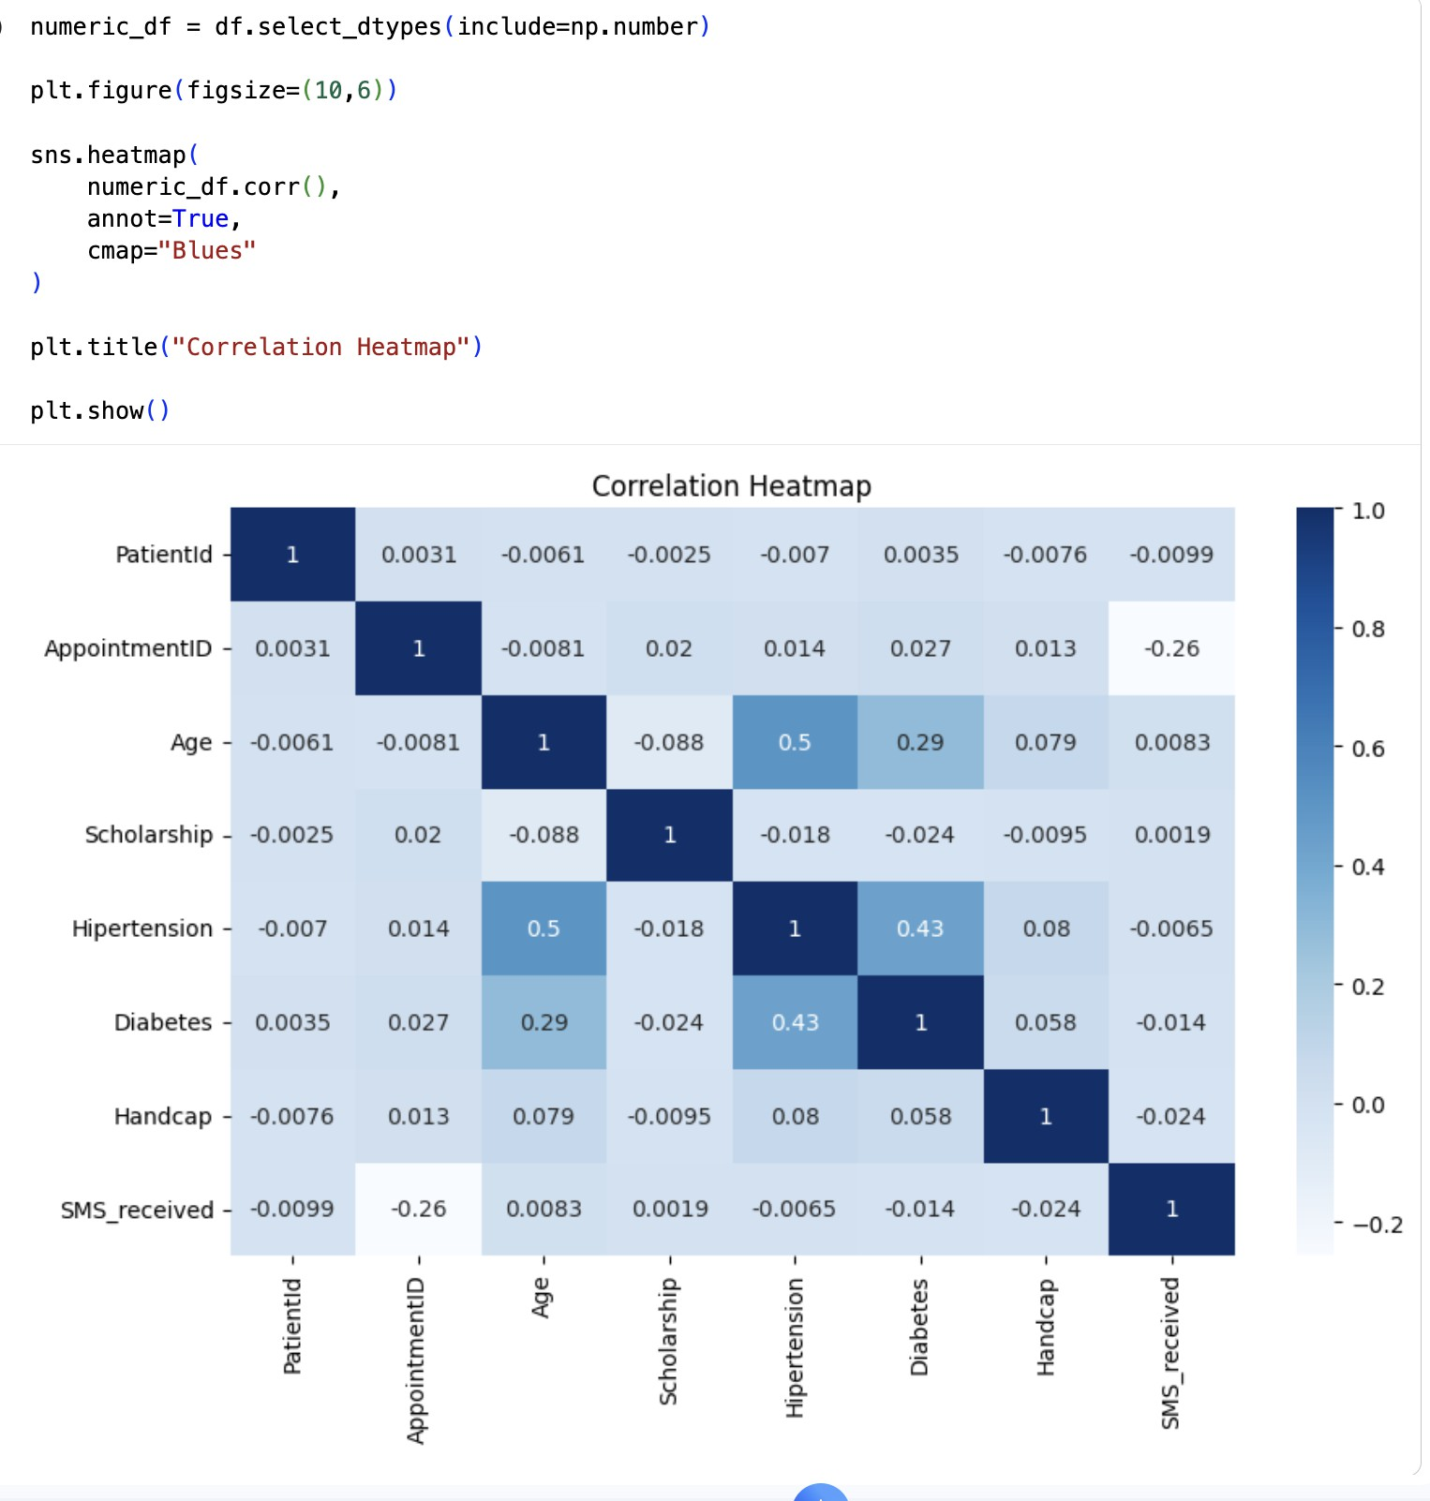

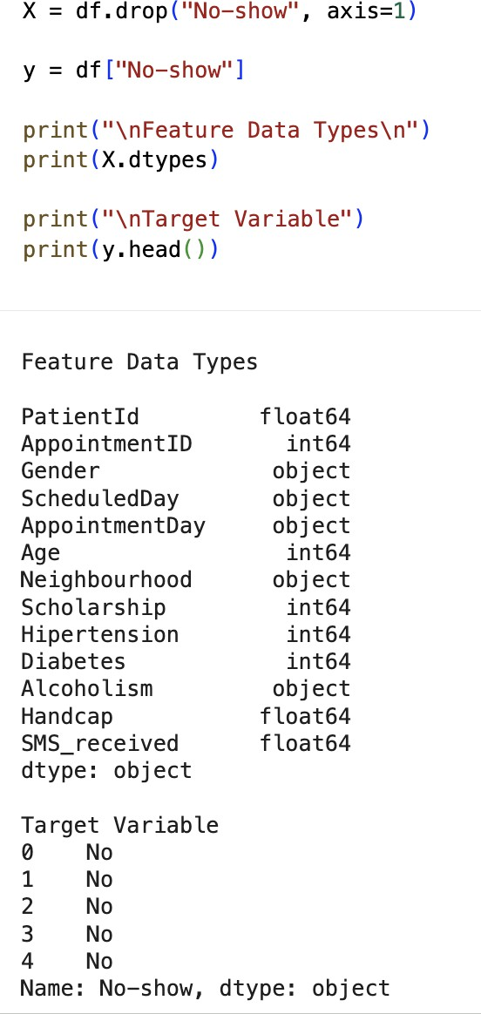

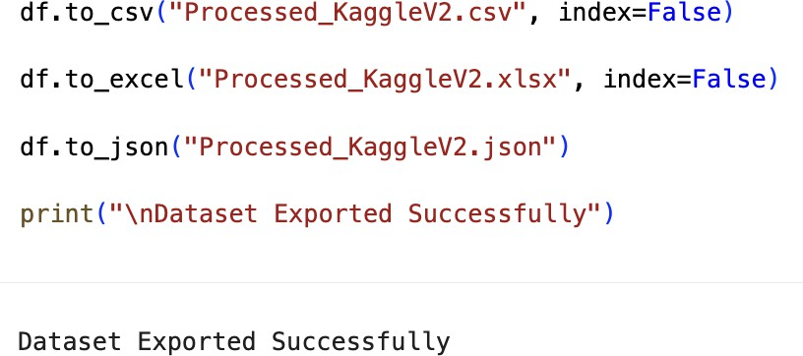

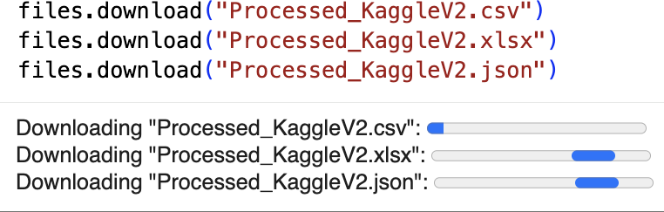

RESULT:
- Thus, missing values, duplicate records, and outliers in the KaggleV2-May-2016.csv dataset were successfully identified and handled. Data transformation techniques such as normalization, label encoding, and one-hot encoding were performed successfully, preparing the dataset for further exploratory data analysis and machine learning applications.

